Exercises:
1. Write a program that accomplish the following purpose:
a) Call the system call to create the child process and store the value returned from the call.
- If the returned value is less than zero,
i. Print ‘Unsuccessful Child Process Creation”. ii. Terminate using exit system call
- If the return value is greater than zero
- Add a wait system call so that the parent would wait for child process to complete.
- Make a loop that prints even numbers from 1 - 10 iii. Print “Parent Ends”
c. If the return value is equal to zero
i. Print the parent ID ii. Make a loop that prints odd numbers from 1 - 10 iii. Print “Child Ends”
b) Stop
- Write a Program that Creates n-child process from same parent process using fork() in C
- Write Program to create four processes (1 parent and 3 children) where they terminates in a sequence as follows:
    - Parent process terminates at last
    - First child terminates before parent and after second child.
    - Second child terminates after last and before first child.(d) Third child terminates first.
- Write a program which creates processes 4 processes for parallel programming. Each parent will wait for the termination of its child.
- Implement the following 9 tree structure. Each node must print its name and PID.
e.g. I am Process A and my PID is 2453
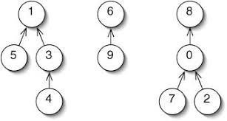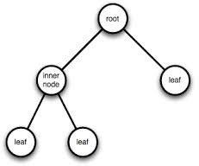
6.

